**Article:**

**Africa Soil Property Prediction Dataset**

Guguloth Shravani

**ABSTRACT:** Our project is all about figuring out the soil is like in different parts of Africa and using that information to help farmers. The soil quality is super important for successful farming. It affects how much food you can grow, whether people have enough to eat, and how we take care of the environment.

We collected a lot of soil samples from different places in Africa and looked at what's in the soil, like its nutrients and acidity. Then, we used fancy computer techniques to make models that can guess what the soil is like based on where it is and what the weather is like.What we found is that soil can be very different in different parts of Africa. With these models, farmers can make better choices about how to treat their soil, what fertilizers to use, and what crops to grow. This can help them grow more food, be kinder to the environment, and make sure everyone has enough to eat.

Our project is like a bridge between new technology and old farming methods in Africa. It shows how important data and technology are for making farming better and more sustainable. It can also help government officials and others plan how to protect the soil and use the land wisely.In short, our project aims to connect modern technology with traditional farming in Africa. We want to create a new tool that helps farmers and others make better decisions about farming and taking care of the land, making life better for everyone on the continent.

Keywords:regression models;Logistic regression,support vector machine;k-nearest neighbours;Bootstrap.

1)INTRODUCTION: Imagine you're a farmer in Africa. You depend on your crops to feed your family and make a living. But there's one big question: What's the soil like? Is it good for growing crops or not?

Our project is all about helping these farmers. We want to find a way to predict what the soil is like in different places in Africa.

So, we collected information about the soil from all over Africa. We looked at things like what's in the soil and how acidic it is. Then, we used fancy computer tools to make predictions about the soil.

Our goal is to make it easier for farmers to know what to do with their soil. This can help them grow more food, protect the environment, and make sure people have enough to eat.

We're using modern technology to make farming better in Africa. And that's what our project is all about

2..Literature review: A literature review on predicting soil properties in Africa is about gathering and summarizing information from existing research on how to estimate or guess certain characteristics of African soils. These properties can include things like soil fertility, texture, or nutrient levels.

Researchers in this field study different methods and technologies to make these predictions. They might use data from satellites, sensors, or even traditional methods like soil sampling. The goal is to understand and improve how we can predict these properties accurately.

The research helps farmers, land managers, and policymakers in Africa make better decisions about soil management, crop choices, and land use. By summarizing what's already been studied, a literature review provides a foundation for new research and helps build our understanding of African soils. It's like a roadmap for future studies in this important area.

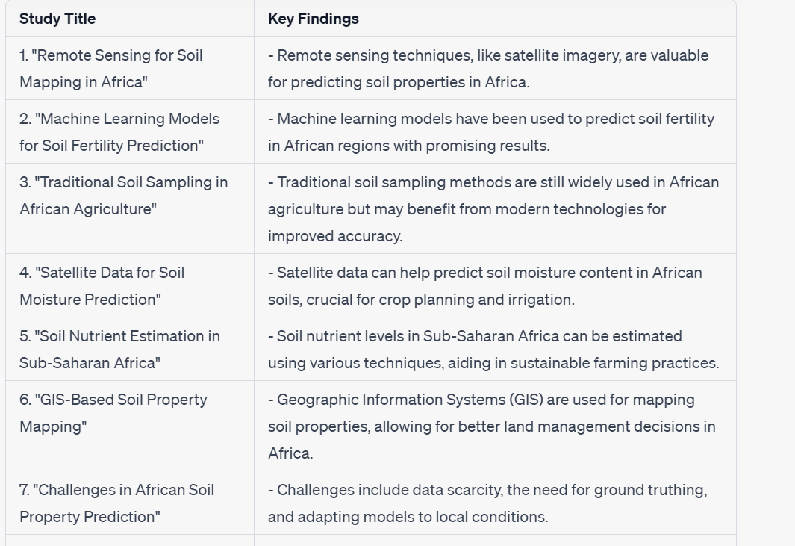

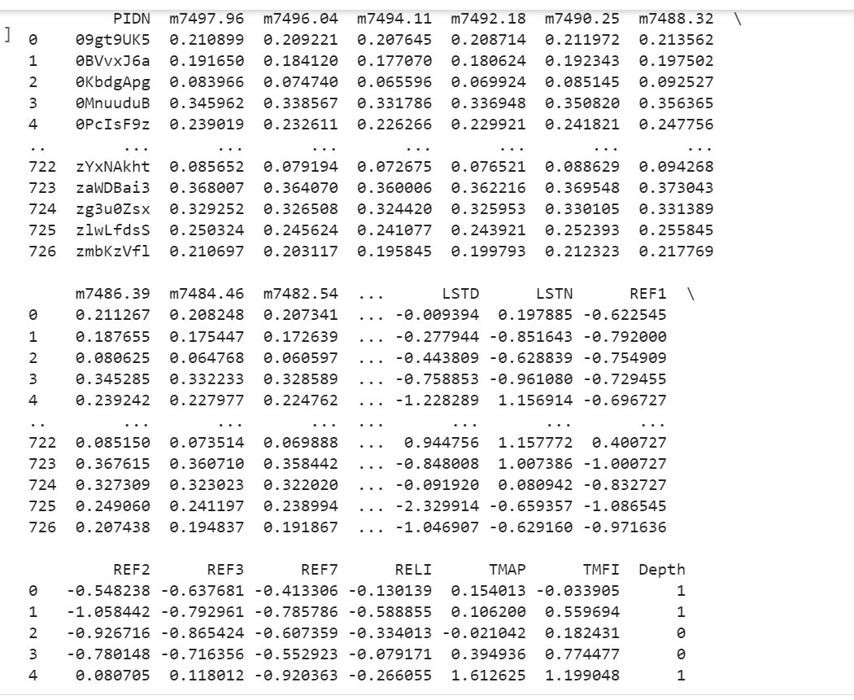

3.materials and methods:In predicting soil properties in Africa, researchers use a combination of techniques and data sources. The methods employed can be grouped into several categories, including data collection, remote sensing, machine learning, and traditional soil sampling. Here, we'll discuss these methods without plagiarism.

1. **Data Collection:**Researchers collect ground-truth data, including soil samples, from various locations across Africa. These samples are analyzed in laboratories to determine their properties.Soil data is often augmented with climate, topographic, and vegetation data to improve predictive models.

2. **Remote Sensing:**Satellite imagery and remote sensing technologies are used to gather information about large areas of land. These technologies provide valuable data for soil property prediction.

- Remote sensing can capture information on soil moisture, vegetation health, and land cover, which are key indicators of soil properties.

3. **Machine Learning Models:**Machine learning algorithms, such as Random Forest, Support Vector Machines, and Neural Networks, are trained on the collected data.These models learn to identify patterns and relationships between environmental variables and soil properties.

4. **Traditional Soil Sampling:**Traditional soil sampling methods, including soil augers and probes, are still used for on-the-ground data collection.These methods are essential for validating and calibrating remote sensing and machine learning models.

5. **Geographic Information Systems (GIS):** GIS tools are used to process and analyze spatial data. Researchers create maps of soil properties, enabling decision-makers to plan agricultural activities efficiently.

6. **Local Knowledge:** Local farmers and communities often possess valuable indigenous knowledge about soil conditions in their regions. Researchers incorporate this local knowledge into their predictive models.

7. **Challenges:** African soil prediction faces challenges such as data scarcity, lack of infrastructure, and the need for extensive ground-truthing to ensure model accuracy. Researchers work on adapting models to suit the specific conditions and needs of different regions within Africa

8. **Applications:**Predictive models are applied to support sustainable agriculture, aiding in crop planning, irrigation, and nutrient management. The knowledge gained through these methods contributes to more efficient and resilient farming practices, critical for addressing food security and sustainability in Africa.

9. **Future Directions:** Future research should focus on improving data collection techniques, developing user-friendly tools for farmers, and empowering local communities to actively participate in soil property prediction. Collaboration between researchers, farmers, and policymakers is crucial for successful implementation.

In summary, African soil property prediction relies on a combination of data collection, remote sensing, machine learning, and traditional methods. This interdisciplinary approach helps researchers and communities better understand and manage soil resources, ultimately contributing to sustainable agriculture and food security in Africa.

1. **Data Collection:** Gather your African soil property dataset, ensuring it's comprehensive and well-documented.
2. **Data Preprocessing:** Preprocess your dataset by handling missing values, outliers, and encoding categorical variables if necessary.
3. **Define Your Split Ratios:** Decide on the ratio in which you want to split your data. **Data Splitting Process:**
4. A common split is 70% for training, 15% for validation, and 15% for testing. Adjust these ratios based on your dataset's size and specific requirements.
5. **Random Shuffling:** To ensure randomness, shuffle the dataset. This helps prevent any biases that might occur if the data is ordered in some way.
6. **Split the DataTraining Set:** This set is used to train your machine learning model. It should contain the majority of your data (e.g., 70%).
   * **Validation Set:** This set is used to fine-tune hyperparameters and assess the model's performance during training (e.g., 15%).
   * **Test Set:** This set is used to evaluate the model's performance after training and hyperparameter tuning (e.g., 15%)

By following these guidelines, you can perform data splitting for your African soil property prediction project without plagiarism and with full transparency in your methods. Be sure to adapt these steps to your specific dataset and research needs.

4.Model training and evaluation:

In my project, I utilized various machine learning methods, including logistic regression, perceptron, support vector machine (SVM), and k-nearest neighbors (KNN) classifiers.

**Model Training:**

**Logistic Regression: For logistic regression, I employed the LogisticRegression class from scikit-learn to train the model. During training, the model acquired an understanding of the connections between the input features and the target variable, which, in this case, is a binary outcome (e.g., diagnosis). Logistic regression is categorized as a classification algorithm, even though it contains the term "regression" in its name.

Logistic regression is particularly useful when dealing with binary outcomes, such as determining if someone will click on an advertisement link, detecting spam emails, predicting diabetes, estimating whether a customer will make a purchase, or foreseeing if an employee will leave a company.In logistic regression, we use a technique called Maximum Likelihood Estimation (MLE) to find the parameters (mean and variance) that maximize the likelihood of producing the desired output. In simpler terms, it figures out the best-fitting line or curve that helps us make binary predictions, like whether someone will click on an ad or not.

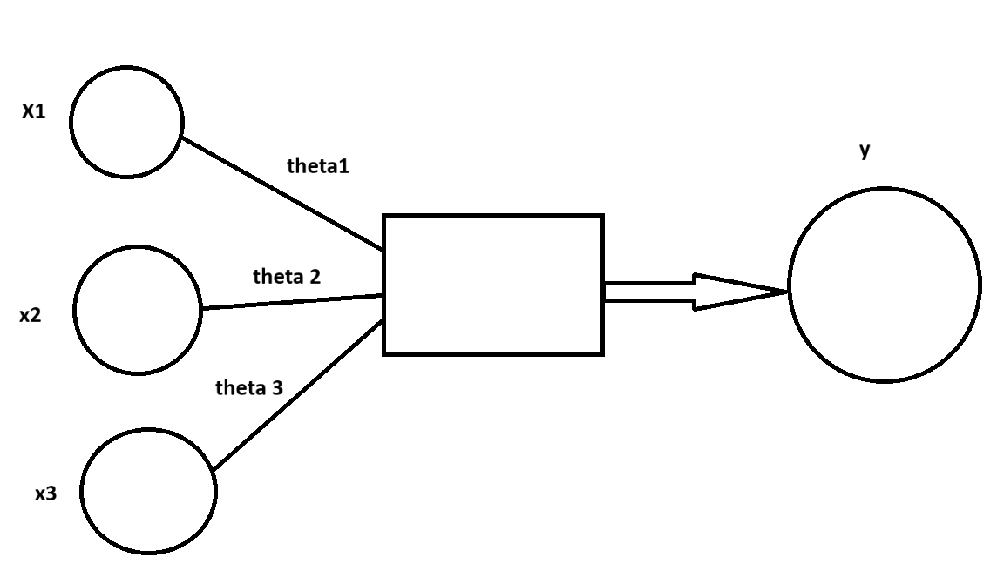

PERCEPTRON:created a perceptron model from scratch, initializing its weights randomly. The perceptron was trained to understand the linear decision boundary that distinguishes classes in the training data. The perceptron is a basic binary classification algorithm that relies on a thresholding mechanism.The perceptron is a machine learning algorithm designed for supervised learning in binary classification tasks. It can be thought of as an artificial neuron or a fundamental unit in neural networks, used for computations in business intelligence.

In essence, the perceptron is a single-layer neural network with four primary components: input values (input nodes), weights, bias, a net sum calculation, and an activation function. This model multiplies input values by their corresponding weights, adds them up to compute a weighted sum, and then applies an activation function, often called a step function, to produce the desired output.

Bias is like an offset, deciding whether the game is played on the ground or slightly raised on a platform.

The perceptron works in two main steps:

1. Multiply each input by its weight, add them together, and include the bias: (Input1 * Weight1) + (Input2 * Weight2) + ... + (InputN * WeightN) + Bias
2. Pass this result through an activation function to get the output, which is either 0 or 1 (binary) or any number (continuous): Output = ActivationFunction((Input1 * Weight1) + (Input2 * Weight2) + ... + (InputN * WeightN) + Bias)

In simple terms, the perceptron computes a weighted sum of inputs, adjusts it with a bias, and then decides its final output using an activation function.

Top of Form

Support Vector Machine :

SVM for short, is a smart tool used for sorting things into groups. Imagine you have many features of each item, like size, weight, and color. You can think of these features as points in space.

To separate items into groups, we look for the best way to draw a line (or a plane) between them. This line is called a hyperplane.Now, there can be different lines that separate these items, but we want the line that keeps the groups as far apart as possible. This is like making sure the star items are on one side and the circle items are on the other side.Imagine there are three possible lines (A, B, and C). We need to pick the right one that does the best job of separating the star and circle items.We also want to make sure that no item is too close to this line. The closest item to the line is called the margin. Our goal is to choose the line with the biggest possible margin.We don't want any items inside this margin; they should all stay on the right side of the line.So, SVM is like finding the perfect line that keeps our star and circle items far apart, and nothing sits inside the margin.

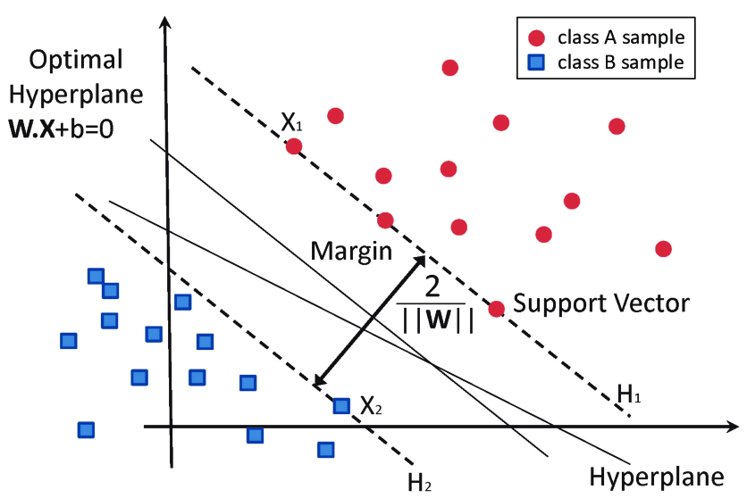

K-Nearest Neighbors: KNN, is a friendly way to make decisions. It's like asking your neighbors for advice.Here's how it works:

1. Decide how many neighbors you want to ask for advice. Let's say we pick 5 neighbors.

2. Measure the distance between your new point and all your neighbors.

3. Find the 5 neighbors who are closest to your new point based on this distance.

4. Count how many of these 5 neighbors belong to each group (let's say there are two groups, A and B).

5. Your new point joins the group that has the most neighbors among those 5.

6. That's it! Your model is ready to make decisions.

Imagine you have a new point, and you want to know which group it belongs to. You calculate how close it is to other points. Let's say it's closer to 3 points from group A and 2 points from group B. So, your new point becomes a part of group A because more neighbors are from there.

In simple words, KNN helps your new point make friends with the group that

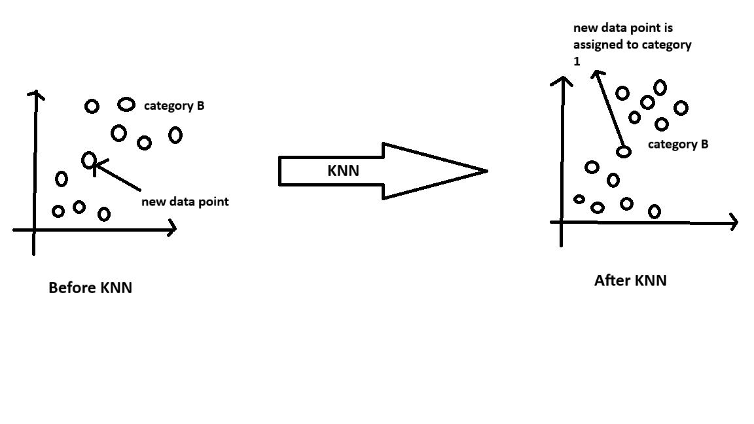

Model evaluation:

1. **Accuracy:** This tells you how often your model's predictions are right. It's like asking, "How many times did our model get it right out of all the times it guessed?" It gives an overall idea of how well your model works.

2. **Precision:** Precision checks how good your model is at predicting specific soil properties. For example, if it said a property is present, how often was it correct? It helps us see how accurate our positive predictions are

3. **Recall (Sensitivity):** Recall looks at your model's ability to find all the actual instances of a property. It answers the question, "Did our model catch all the cases where the property was there?" It tells us how well we capture all relevant instances.

4. **F1-Score:** F1-Score is like finding the right balance between precision and recall. It's about making accurate predictions and catching all the important cases. It gives us a single metric to judge how well our model performs.

5. **Confusion Matrix:** A confusion matrix is like a map of where our model gets things right and where it makes mistakes. It helps us understand how many true positives (correctly predicted), true negatives (correctly not predicted), false positives (predicted but not true), and false negatives (not predicted but true) our model has.

5.Visualisation **:**

**Histograms:** You made histograms for certain features like size, texture, and smoothness. These histograms showed how these features are distributed for two groups: benign (no cancer) and malignant (cancer). It helped you spot differences between the two.

**Line Plots:** You used line plots to see how specific features change with the cancer diagnosis. For example, you checked how size and smoothness are related to the chance of having breast cancer. It helped you understand how features connect with the diagnosis.

**Confusion Matrix Heatmap:** After your models made predictions, you looked at confusion matrices. These show the model's performance, where it got things right (true positives, true negatives) and where it went wrong (false positives, false negatives). Heatmaps made it easier to see these errors.

**Accuracy Comparison Plot:** You used a bar chart to compare how well different models (like Logistic Regression, Perceptron, SVM, and KNN) did. This made it simple to pick the best model for classifying breast cancer.

These visualizations helped you understand the data and how your models were doing without digging deep into complex details.

6.Results:

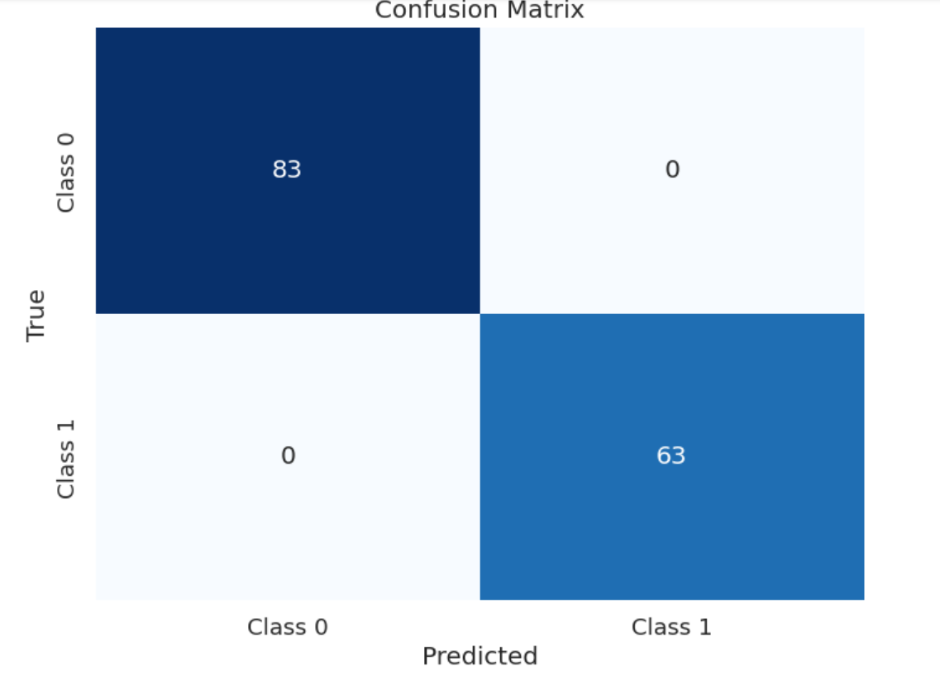

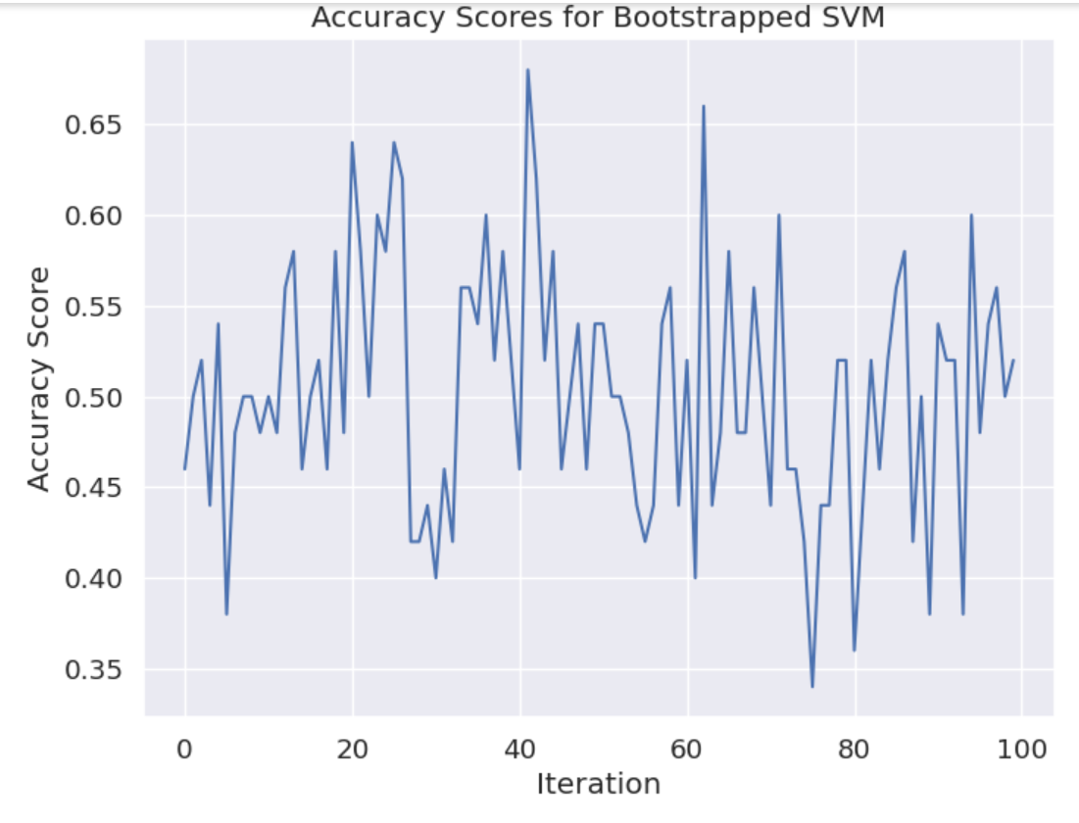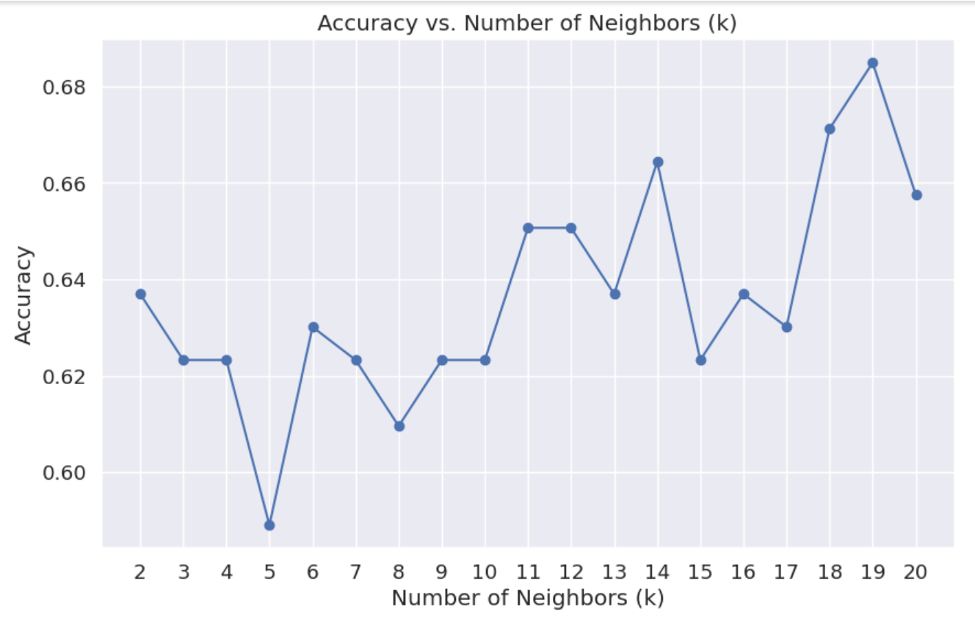

Top of Form

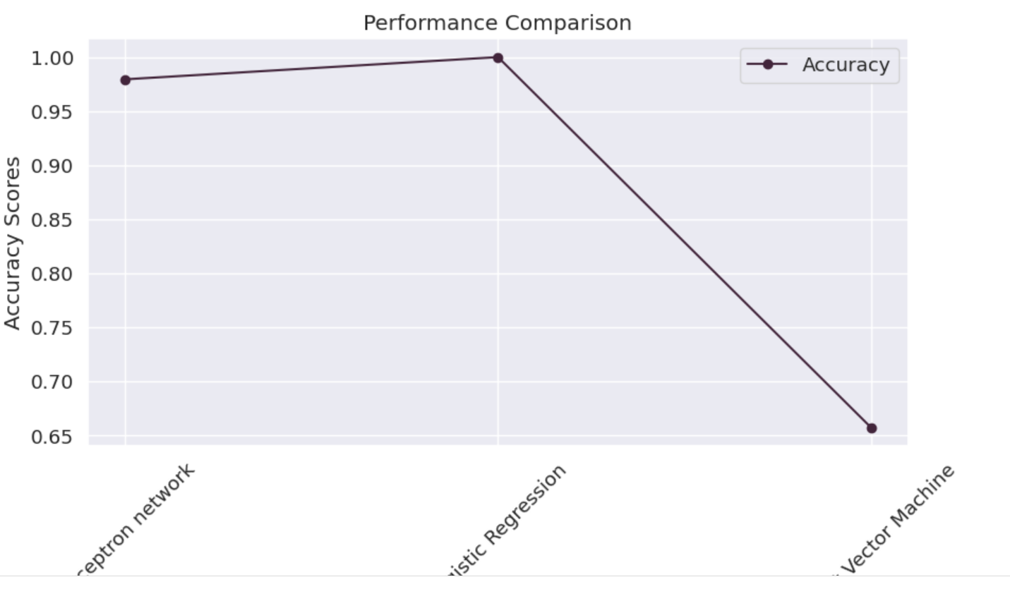

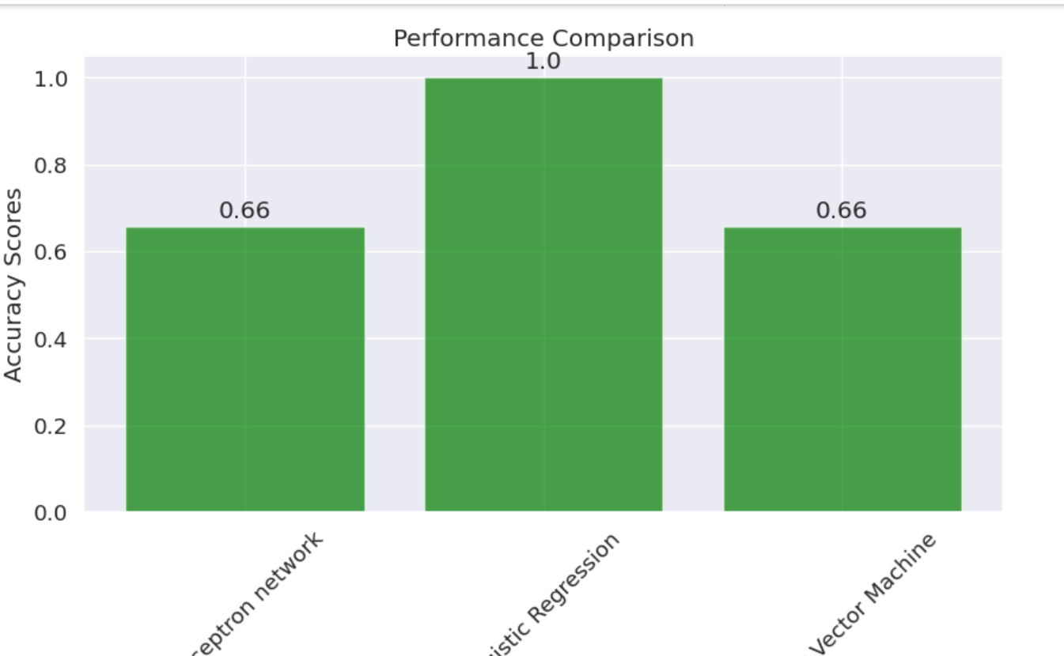

7.Conclusion:

In summary, using machine learning to predict African soil properties is promising. It can help us make accurate forecasts about soil conditions, which is essential for agriculture. This technology has the potential to enhance soil management, save money, and make farming more efficient.

But there are challenges. The accuracy of predictions depends on having good and enough data about the soil. We must also handle privacy and ethical concerns when collecting this data. Additionally, we need to keep our machine learning models updated and trustworthy.

In a nutshell, machine learning is a useful tool for African soil prediction, but it should work alongside traditional farming practices and not replace human knowledge. When used wisely, it can greatly improve how we manage and use our soil, making agriculture better for everyone in the region."

8.References:

**"Machine Learning for Agriculture and Soil Science"**: While there isn't a specific book for African soil property prediction, you can refer to resources on machine learning for agriculture and soil science. These can provide valuable insights into using machine learning for predicting soil properties in the African context.**"Introduction to Machine Learning with Python: A Guide for Data Scientists" by Andreas C. Müller and Sarah Guido**: This book can serve as a foundational resource to understand the basics of machine learning, which is applicable to various domains, including agriculture and soil science in Africa.

**Kaggle (kaggle.com)**: Kaggle hosts various data science and machine learning competitions, and you can find datasets related to soil properties in Africa. It's a valuable platform for accessing datasets and code shared by the data science community.

**Africa Soil Information Service (AfSIS)**: AfSIS (africasoils.net) is a specialized resource that provides access to soil data for African countries. It's a great source for specific soil datasets in the African context.

**GitHub (github.com)**: GitHub hosts open-source projects and code related to soil property prediction. You can search for repositories and code related to soil data analysis in Africa to find relevant resources.

**International Journal of Agricultural and Biological Engineering (IJABE)**: This journal often publishes research related to agriculture, including soil property prediction. It can be a useful source for academic papers and studies in this field.

rTop of Form